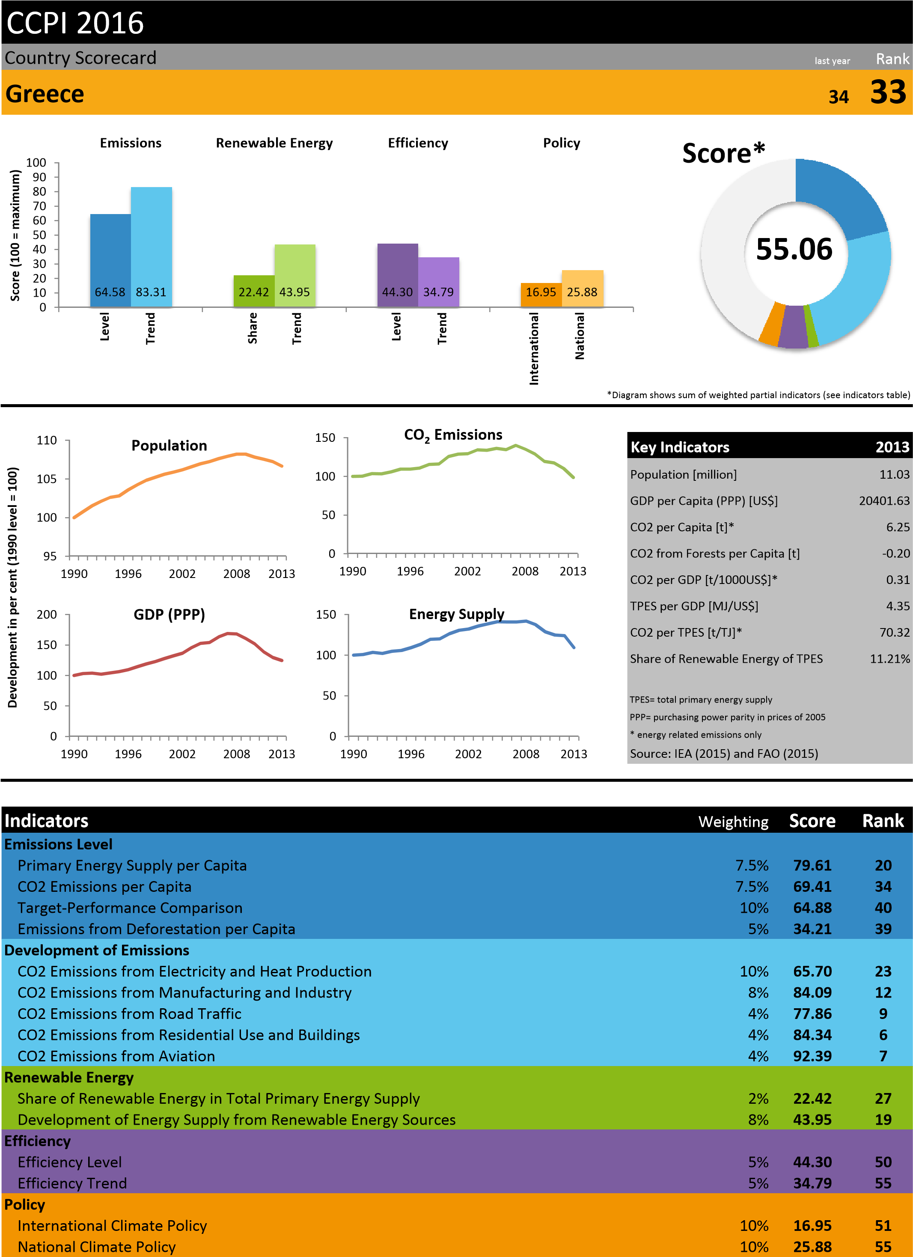
Results of the Germanwatch Climate Change Performance Index
www.germanwatch.org/en/ccpi ©Germanwatch 2015
CCPI 2016
Country Scorecard | last year Rank
Greece ₃₄ 33





Historic CCPI Ranking Greece*
0
20
40
60
80
100
120
140
160
1990
1996
2002
2008
Development in per cent (1990 level = 100)
Development of Key Indicators
CO2 Emissions
CO2/GDP
CO2/TPES
CO2 per Capita
33
34
49
49
43
0
10
20
30
40
50
60
70
2016
2015
2014
2013
2012
* using revised CCPI methodology (see www.germanwatch.org/en/ccpi_bame) h
Selected comments from national experts
- Experts criticize that at this moment the market for renewable energies were not running as a result of previous policies. Main priorities for the previous government would have been the expansion of lignite power generation, the promotion of oil and natural gas explorations and the construction of hydrocarbon infrastructure. No amendments to old and inefficient lignite plants were made. - The signing of the contracts for the interconnection of some of the Greek islands that rely on out-dated diesel plants for electricity generation has been evaluated as positive development.
- Policies for reducing the CO2 footprint of the transport sector include an incentive scheme for Liquefied Petroleum Gas (LPG) passenger vehicles, the development of the Thessaloniki metro system and the extension of the Athens metro system, but are not yet realised.
- The new net-metering law would have a good potential, however more incentives for energy efficiency investments need to be supported. During the reporting period no actual progress has been made with regards to energy efficiency at building level.
- Forest areas are currently protected by the National Constitution and by the forest legislation against land use change. Though, new bills legalise several constructions and installations in forest lands. At the same time there are significant problems with efficient implementation of national legislation, primarily due to the lack of forest mapping. Furthermore, currently forests are subjected to increasing logging pressures for domestic fuel use. At the same time forest authorities can only partially control these pressures due to lack of personnel and funding.
- Due to the economic crisis Greece has no climate policy nor does it plan to develop one as it is not in the current government’s priority.
Results of the Germanwatch Climate Change Performance Index
www.germanwatch.org/en/ccpi ©Germanwatch 2015

